$599-Custom 3 month plan to:

- Develop Your Brand
- Grow Your Platform
- Sell More Books

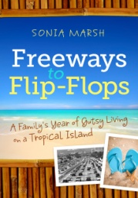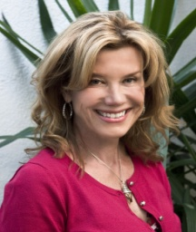
Sonia Marsh

- Includes the following Steps 1-3 in the $249 Custom Marketing Plan
- Develop a Brand and a Social Media plan specific to you
- 3 follow-up phone/Skype calls/ (60-minutes) to discuss your progress and answer questions

All the information you need to jumpstart your book sales
Step 1:
- A 90-minute phone, Skype or Google+ Hangout where I interview you about your book, get a feel for a strategy that suits your personality, and determine the best marketing plan for you.
Step 2:
- I prepare a one-page customized plan based on specific locations, organizations, and companies that fit your ideal target market.
- I suggest what brick and mortar stores you should approach first.
- I outline an online marketing strategy based on your social media skills and where to focus your time.
Step 3:
- You review your customized plan, and we schedule a 30-minute consultation to discuss how to implement your plan and answer your questions.
You get all the information you need to jumpstart your book sales. ONLY $249
ONLY $599.00

Sonia Marsh is the award-winning author of a travel memoir, who now offers "gutsy" book marketing and coaching to indie authors. Contact her at: sonia@soniamarsh.com or visit her website: http://soniamarsh.com

