A Customized Marketing Plan for You To Sell Your Book

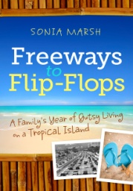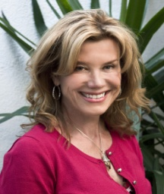
Sonia Marsh
- You’ve written a book but no one is buying it.
- You want to reach out to potential readers, but how?
- You have no idea how to market or sell your book.
- You wish you had someone who could sell your book while you stay home in your pajamas and write the next one.

To become a successful author, you need a strong marketing plan.
I help you develop a customized marketing plan that fits your personality, (shy or outgoing) your schedule, and targets your audience. Here’s how it works

All the information you need to jumpstart your book sales
Step 1:
- A 90-minute phone, Skype or Google+ Hangout where I interview you about your book, get a feel for a strategy that suits your personality, and determine the best marketing plan for you.
Step 2:
- I prepare a one-page customized plan based on specific locations, organizations, and companies that fit your ideal target market.
- I suggest what brick and mortar stores you should approach first.
- I outline an online marketing strategy based on your social media skills and where to focus your time.
Step 3:
- You review your customized plan, and we schedule a 30-minute consultation to discuss how to implement your plan and answer your questions.
You get all the information you need to jumpstart your book sales. ONLY $249
ONLY $249.00

Sonia Marsh is the award-winning author of a travel memoir, who now offers "gutsy" book marketing and coaching to indie authors. Contact her at: sonia@soniamarsh.com or visit her website: http://soniamarsh.com

